**Experiment 7**: Create Docker Swarm Cluster

1. Initialize the swarm using the command ‘docker swarm init’. Now run the command shown in the output in the other terminal to appoint it as a worker.

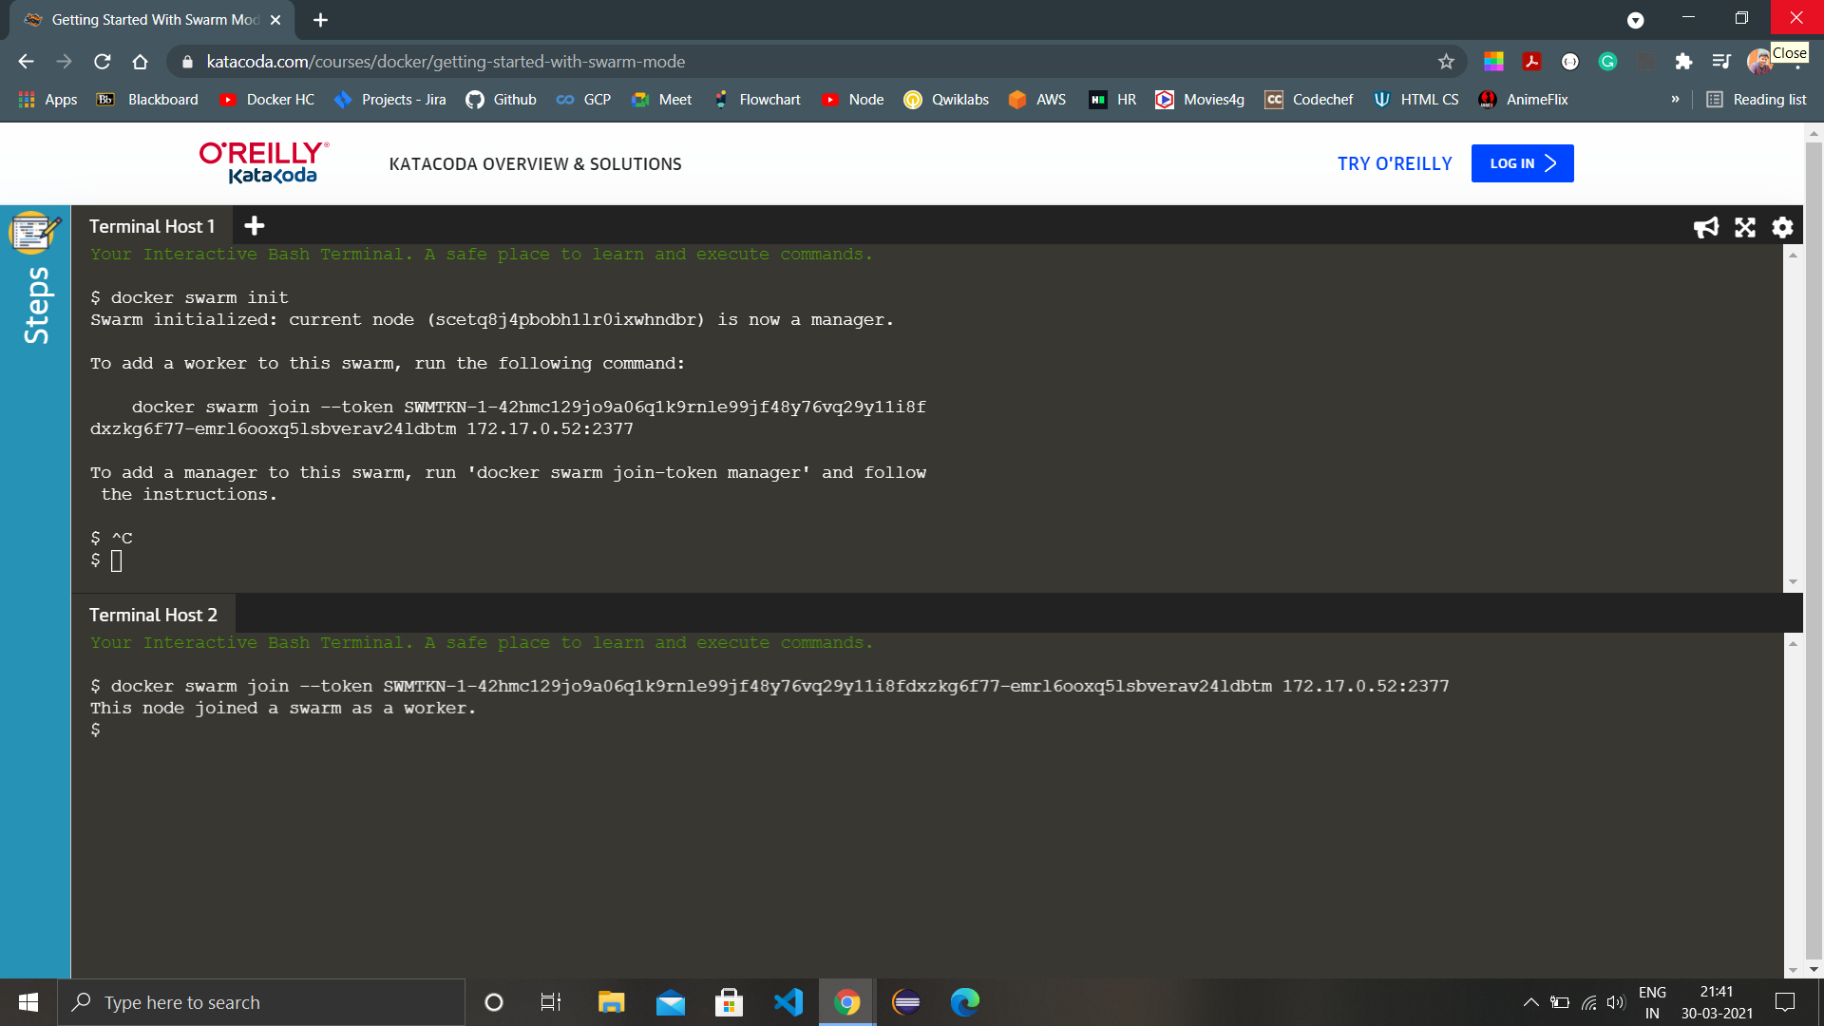

1. Run the command ‘docker node ls’ in the master node to view all the nodes in the swarm.

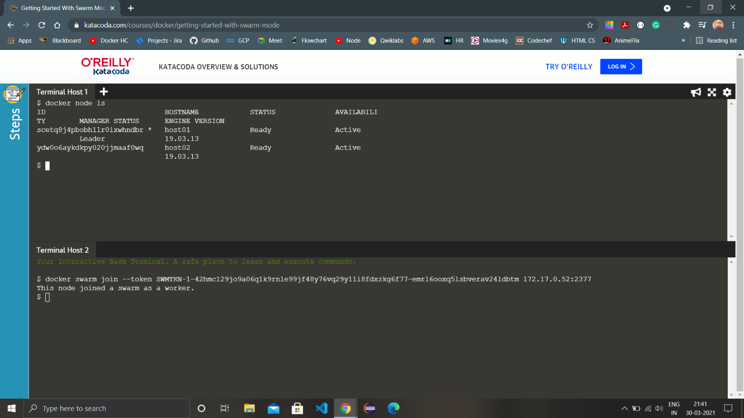

1. Now create a network named Skynet using the command ‘docker network create -d overlay skynet’ and list all the available networks using the command ‘docker network ls’.

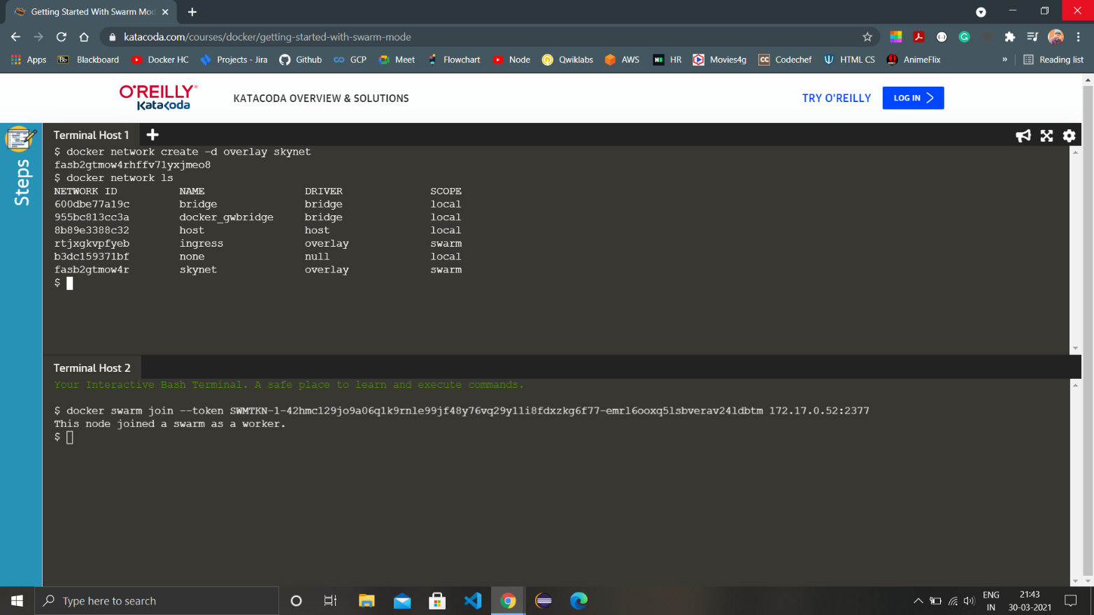

1. Check and list the services using the command ‘docker services ls’. As of now, there aren’t any services available so the command doesn’t have any listing.

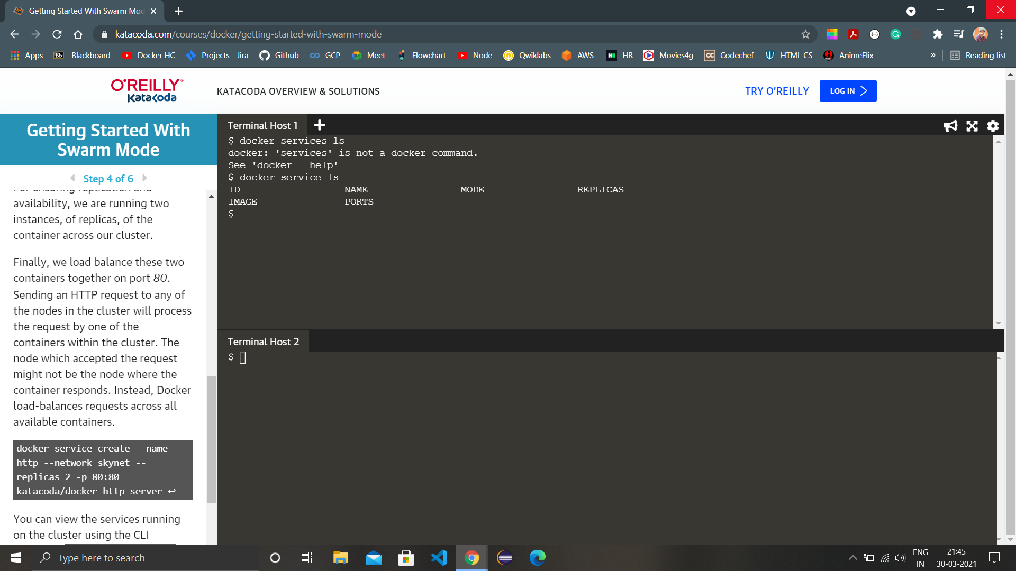

1. Use the command ‘docker service create --name http --network skynet --replicas 2 -p 80:80 katacoda/docker-http-server’ here we are creating 2 replicas and assigning them to the nodes.

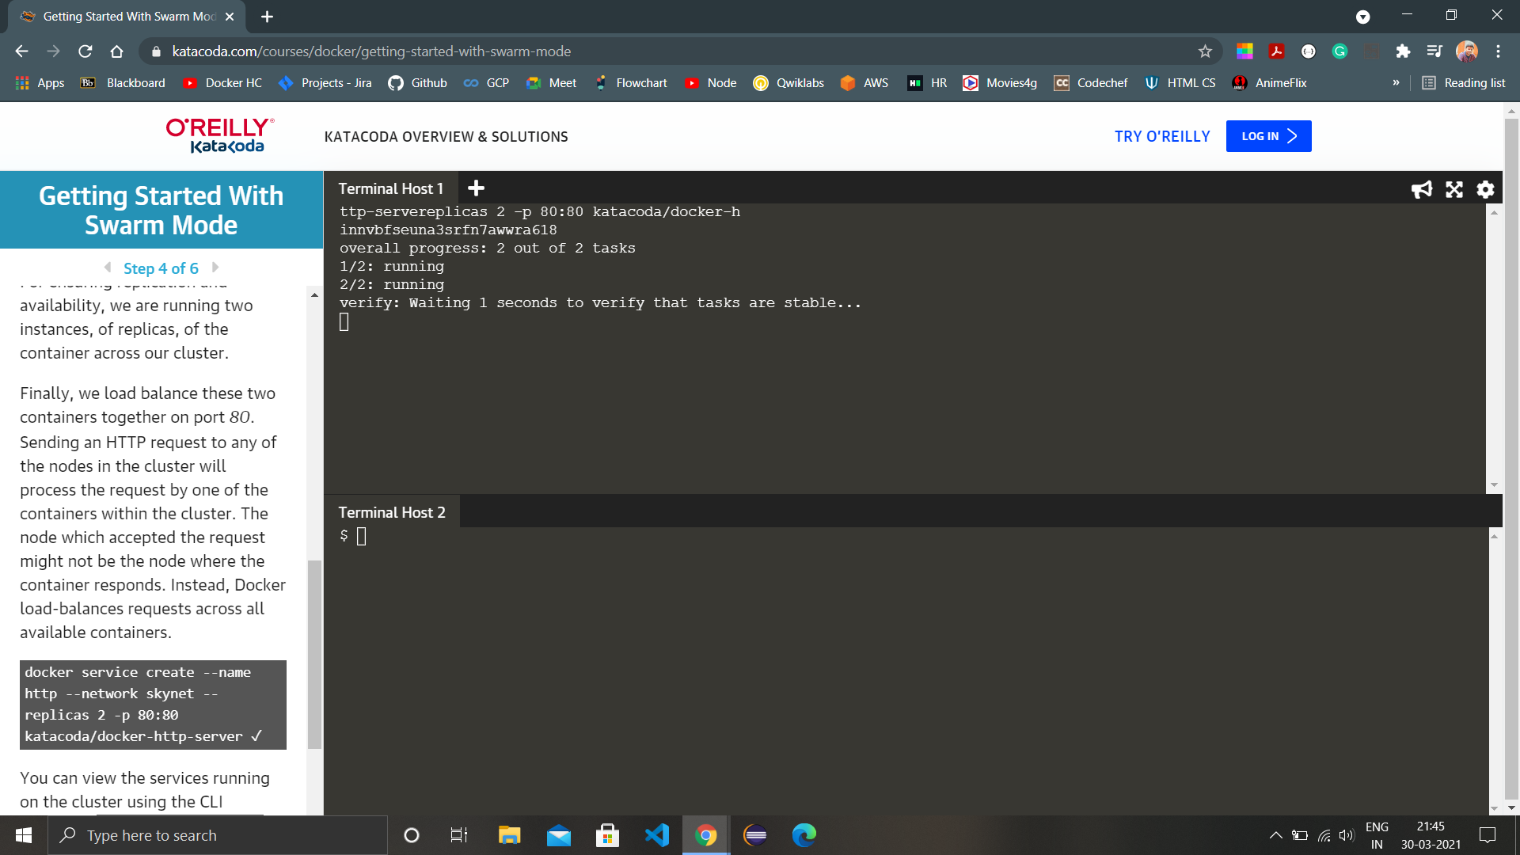

1. Once the service creation is complete, run the command ‘docker service ls’ to list the recently created service.

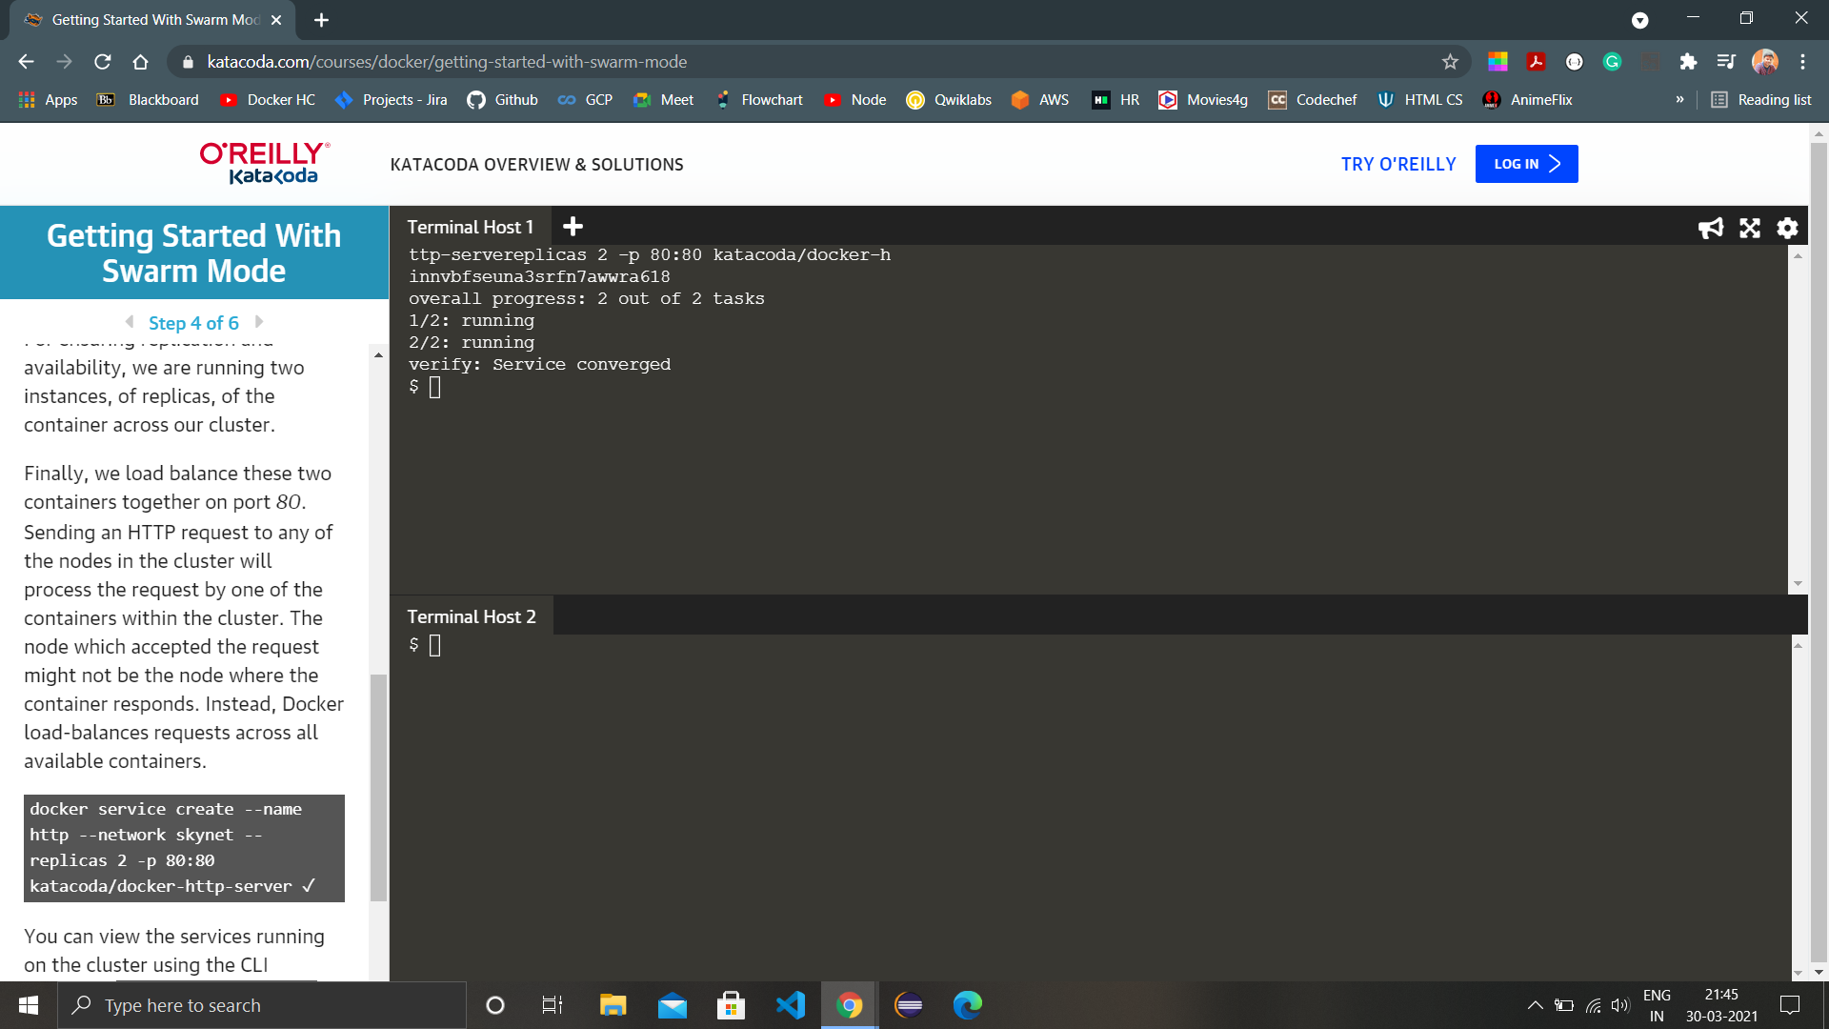

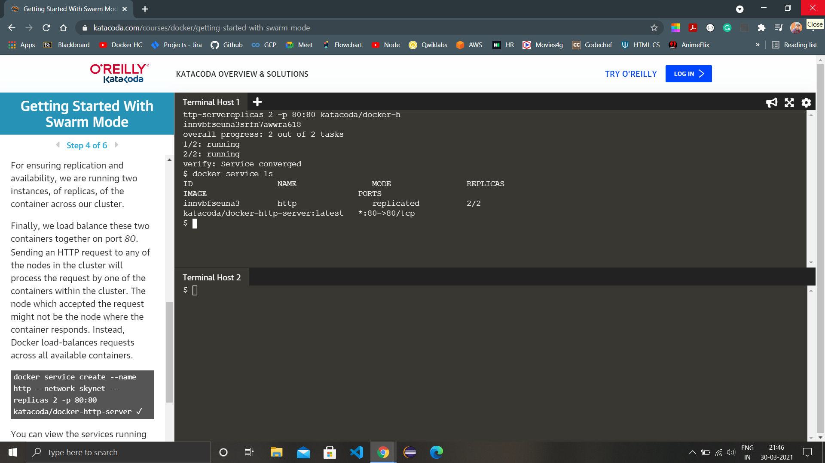

1. Run the ‘docker ps’ command to view the containers running in all the nodes to see the service getting run.

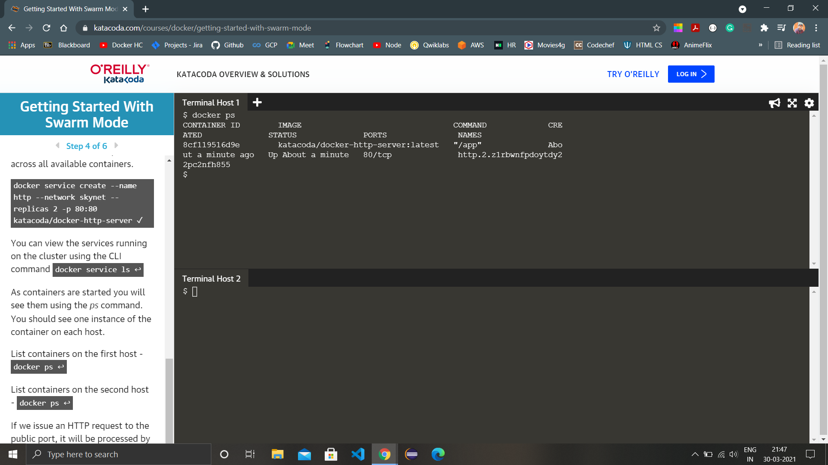

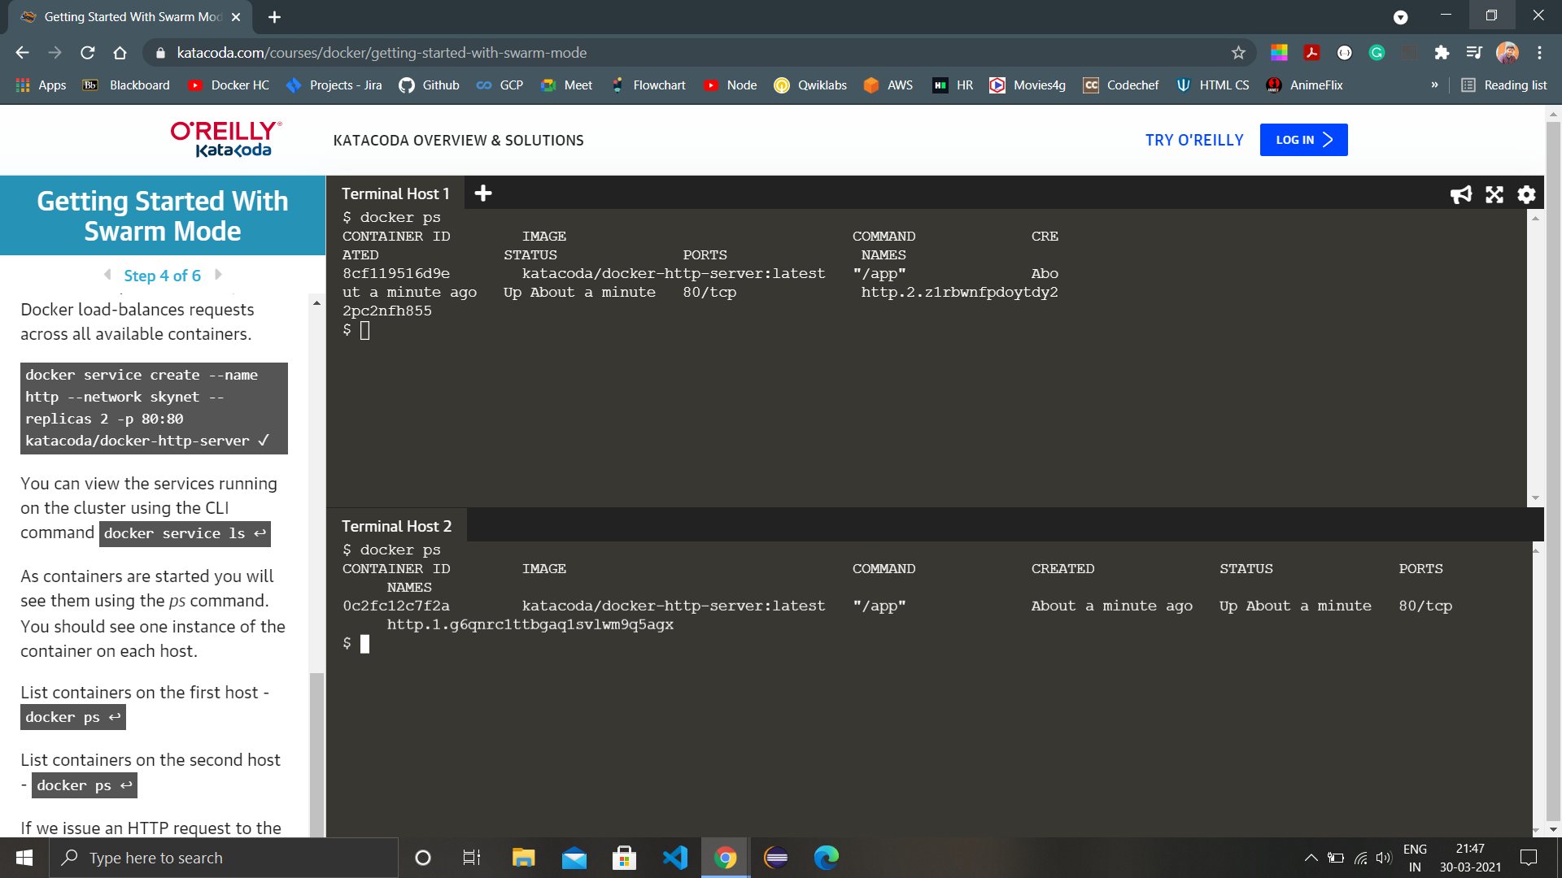

1. Run curl command for host1 in the master node.

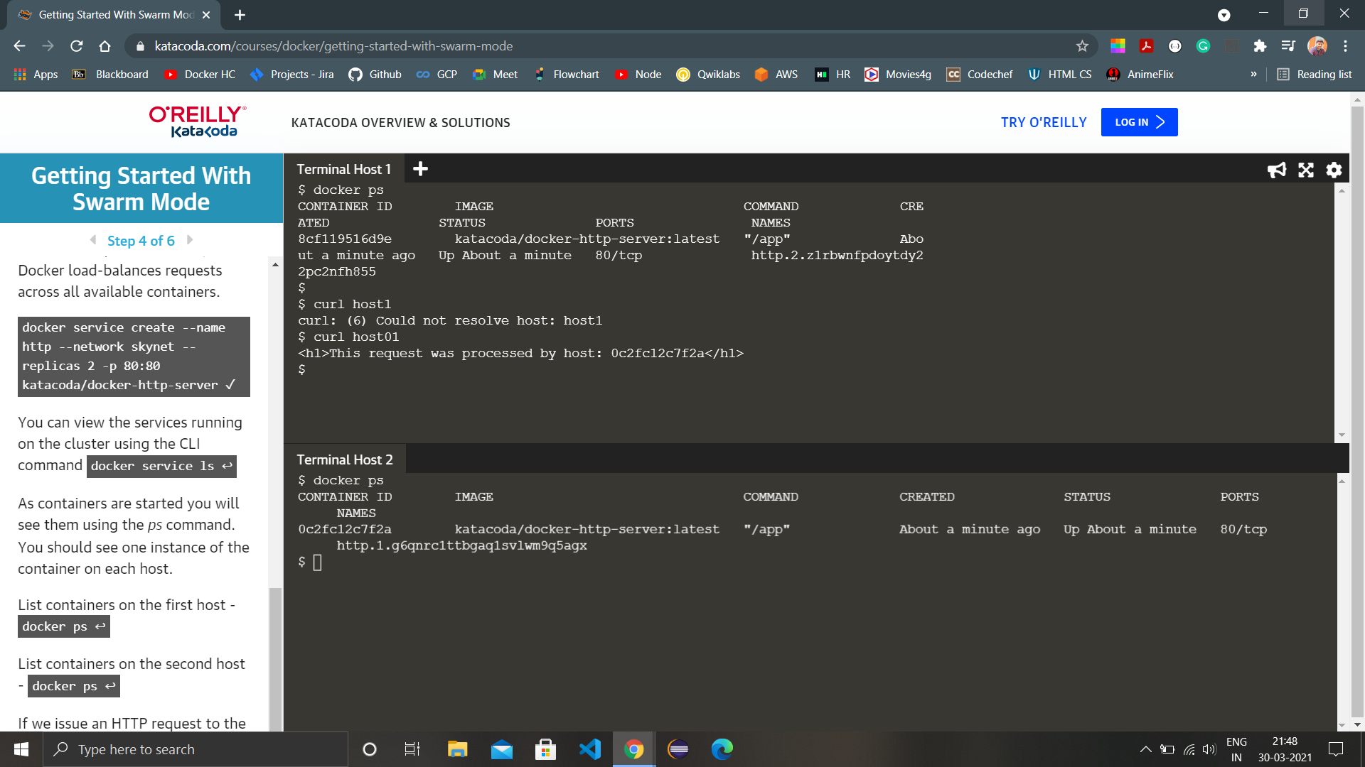

1. We can view the list of all the tasks associated with a service across the cluster using the command ‘docker service ps http’.

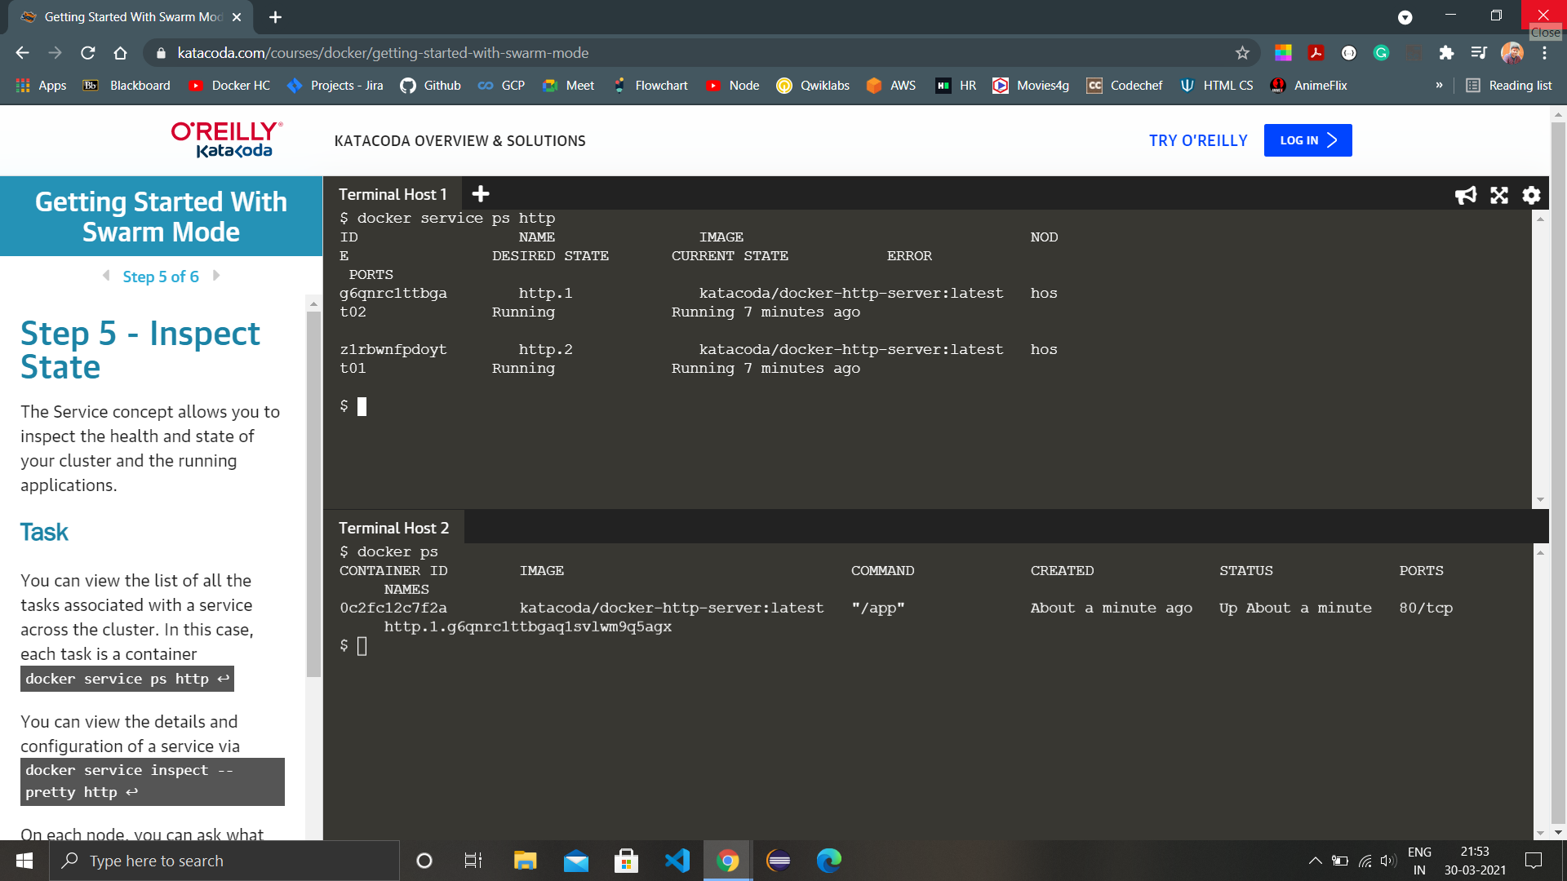

1. Also we can view details and configuration of the service created using the command ‘docker service inspect –pretty http’.

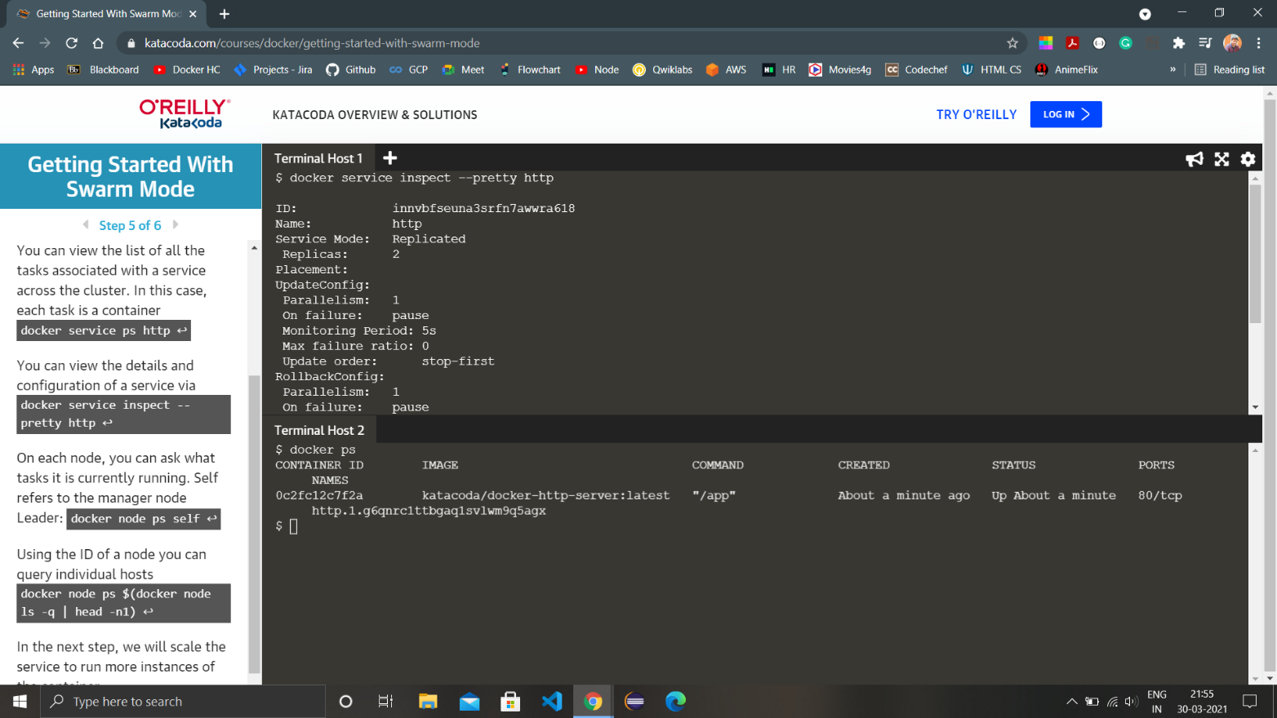

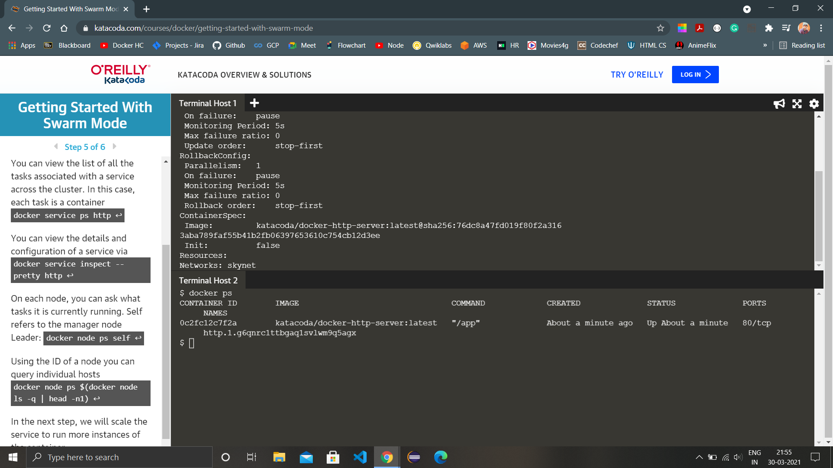

1. We can view what tasks are currently running on each node using the command ‘docker node ps self’.

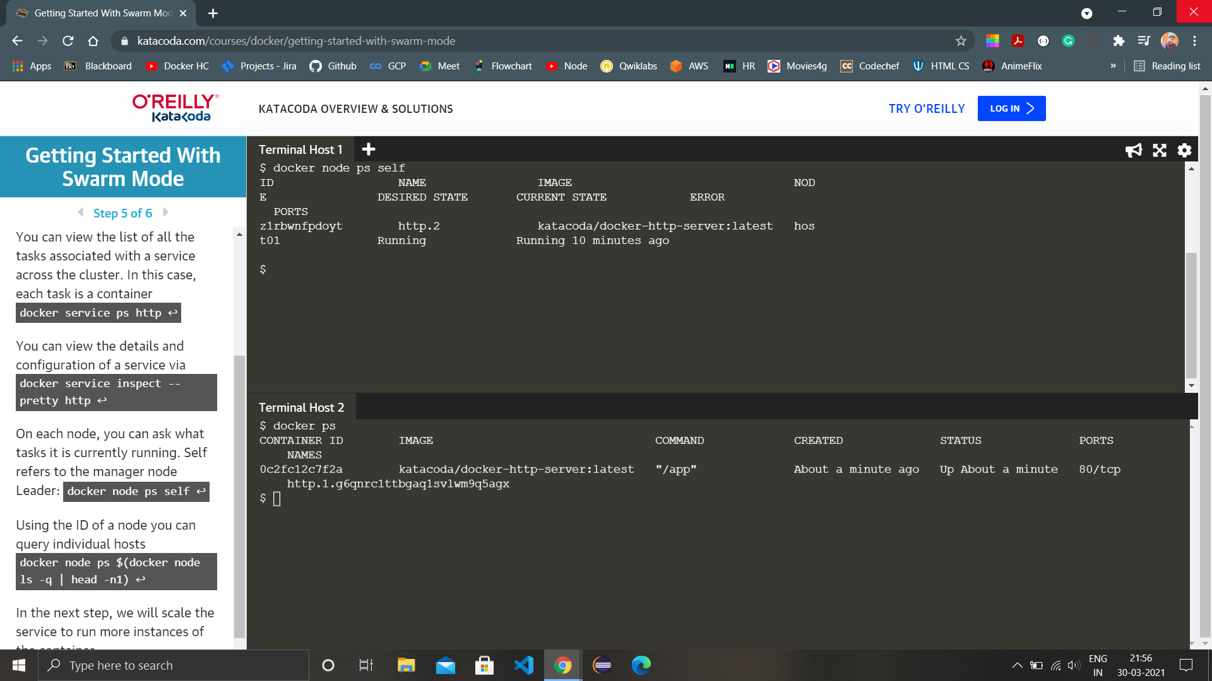

1. For scaling the service we use the command ‘docker service scale http=<no to which we want to scale>’, like here we are scaling from 2 to 5 containers in the service.

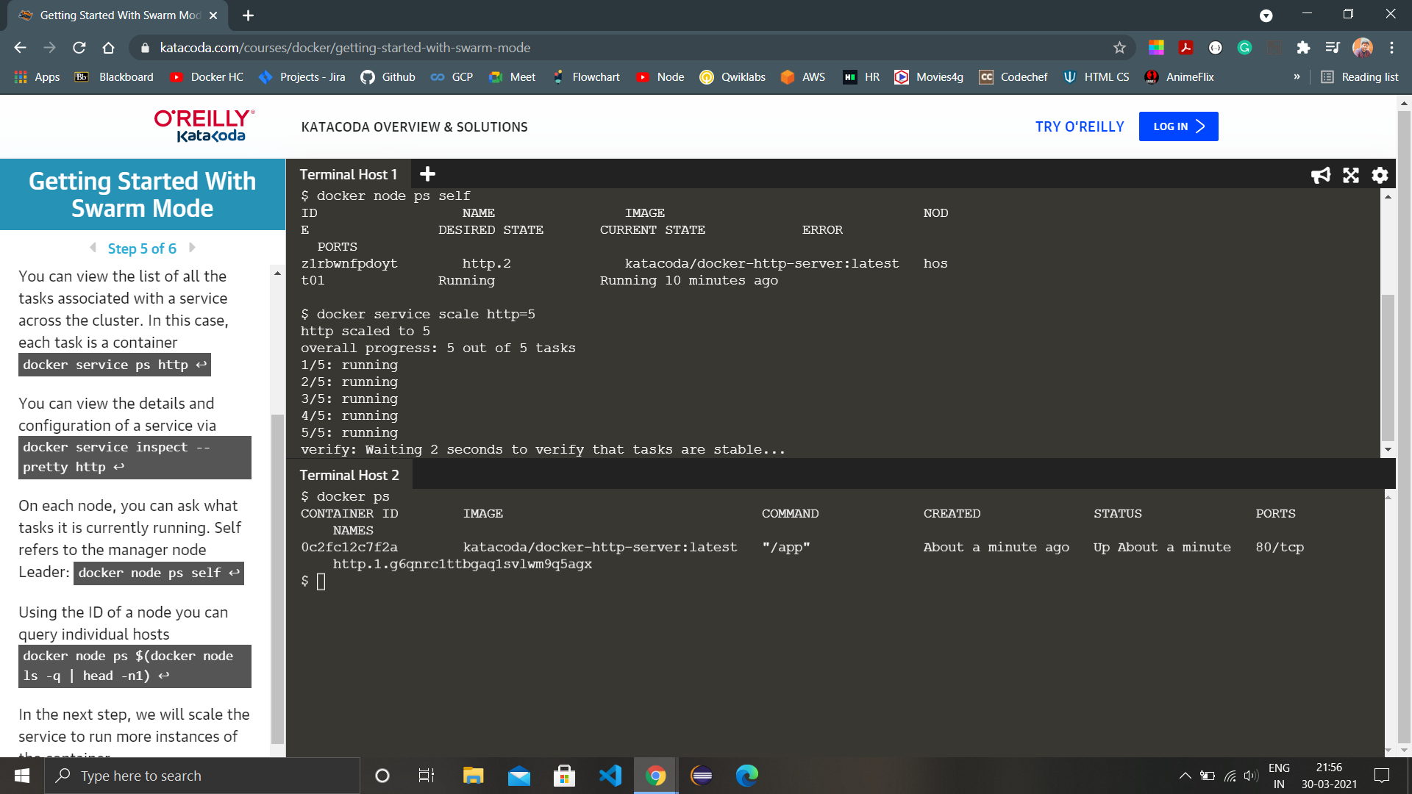

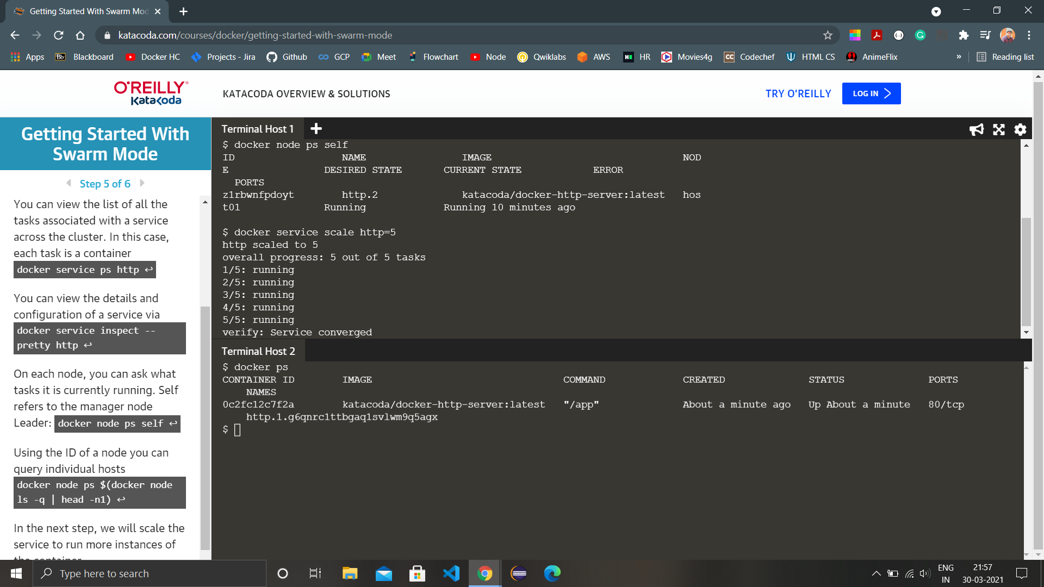

1. Run the ‘docker service ls’ command again to see the change in the service after scaling.

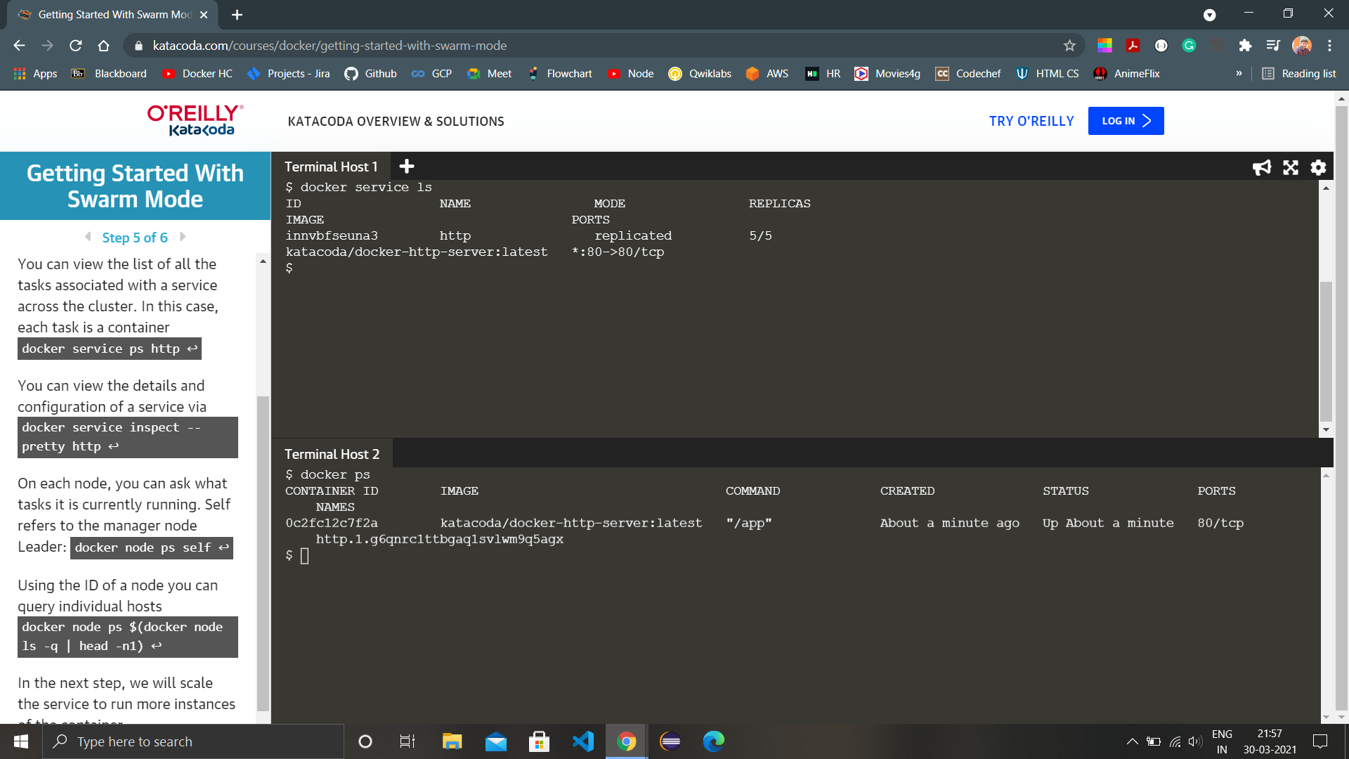

1. Run the command ‘docker ps’ in all the nodes to view the running containers in service.

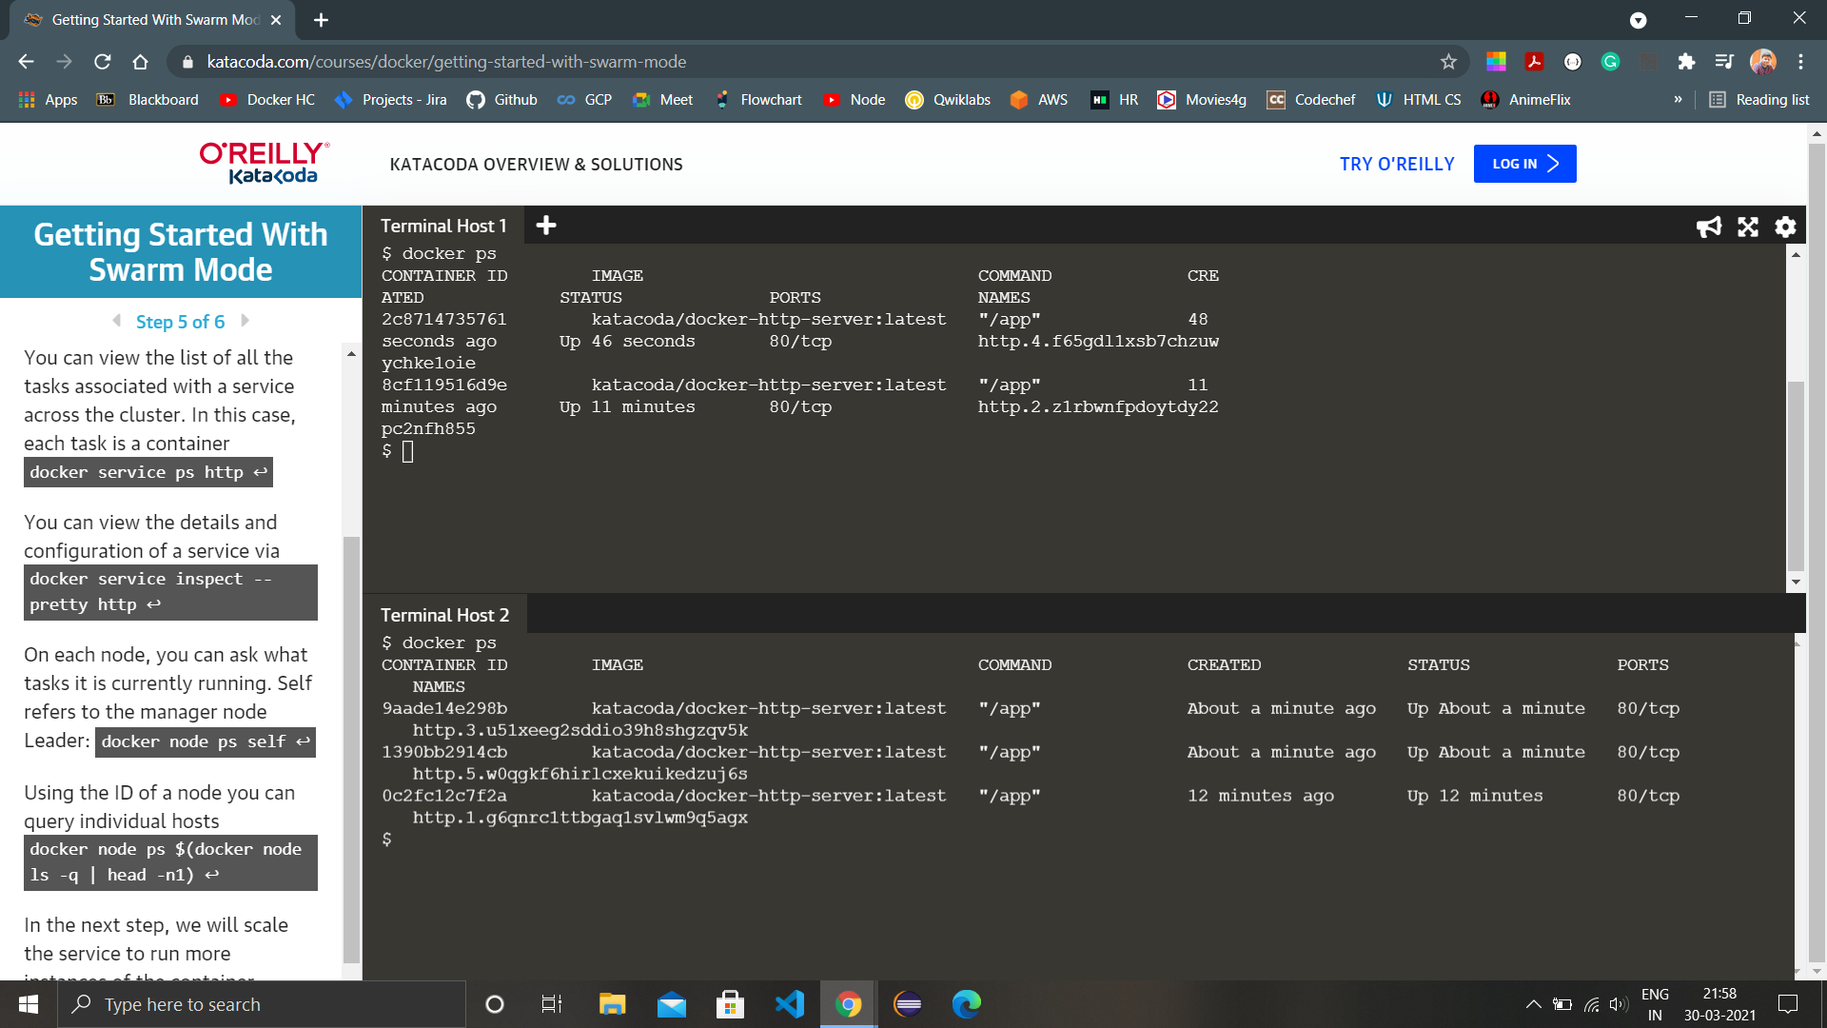

1. To delete a service, run the command ‘docker service rm <service-name>’, here the service is http so the command is ‘docker service rm http’.

